EXPLORE WITH AI: Custom Itineraries for Your Next Journey

Introduction
Project Title: Explore with AI – Custom Itineraries for Your Next Journey
Team ID: LTVIP2026TMIDS61754
Team Members:
- N. Sai Harshitha
- P. Rajitha
- M. Sowjanya
- K. Srilekha
- Afreen Shaik

Project Overview
Purpose:
Explore with AI is an intelligent travel planning web application designed to automate and simplify itinerary creation using Generative Artificial Intelligence (Generative AI).
Travel planning is often time-consuming and overwhelming due to the extensive research required to create personalized itineraries. Both individual travellers and travel agencies struggle to efficiently generate customized and high-quality travel plans.
This project leverages Large Language Models (LLMs) through Generative AI APIs to automatically create structured, detailed, and personalized travel itineraries based on user input such as destination, number of days, and nights.
The system reduces manual effort, eliminates information overload, and provides a stress-free travel planning experience.

Features:
- AI-powered travel itinerary generation
- Generative AI integration using LLM
- Structured Markdown formatted output
- Personalized trip planning
- Day-wise itinerary breakdown
- Morning, Afternoon, Evening, Night schedule
- Travel tips inclusion
- User-friendly web interface
- Real-time content generation
- Cloud deployment capability

Architecture
Frontend:
The frontend of Explore with AI is developed using Streamlit, a Python-based open-source framework for building interactive web applications.
Frontend features include:
- Input field for destination
- Number of days input
- Number of nights input
- “Generate Itinerary” button
- Loading spinner during AI processing
- Markdown rendering of AI-generated itinerary
- Error validation for empty fields
The UI is minimal, responsive, and user-friendly.

Backend (Application Logic):
The backend logic is implemented using Python.
Responsibilities include:
- Handling user input
- Input validation
- Prompt engineering
- Sending requests to Generative AI API
- Receiving and formatting AI response
- Rendering output in Markdown
The application dynamically builds structured prompts to ensure consistent and high-quality output from the AI model.

AI Integration
The core functionality of the project is powered by Generative AI (Large Language Model - LLM).
The AI model:
- Processes structured prompts
- Understands destination and duration
- Generates detailed day-wise itinerary
- Produces output in Markdown format
The model is accessed through a Generative AI API, which processes requests and returns intelligent, context-aware responses.

Infrastructure
The application can run:
- Locally on the user’s system
- On cloud platforms such as Streamlit Cloud
- On Virtual Machines (AWS, Azure, etc.)
The AI model operates on cloud infrastructure, ensuring scalability and reliability.

Setup Instructions
Prerequisites:
- Python 3.8 or later
- Streamlit
- Generative AI API access
- Internet connection

Installation:
Clone the repository:
Navigate to the project directory:

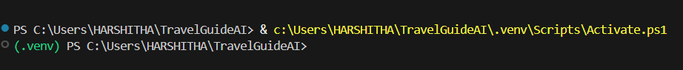

Install required dependencies:
pip install -r requirements.txt

Environment Configuration
Create a .env file and add:
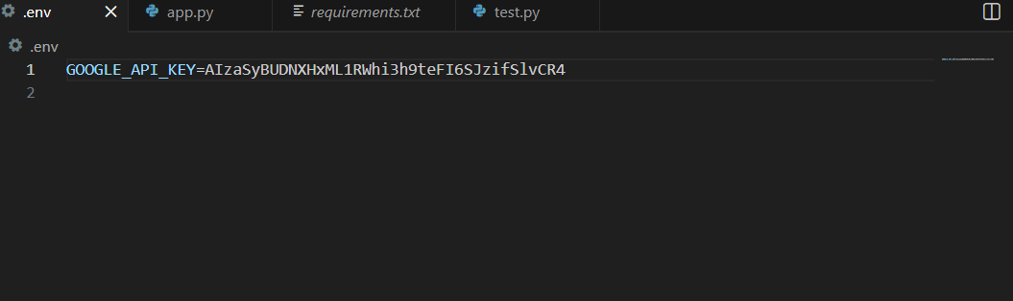

Ensure the API key is not hardcoded in the source code.

Running the Application
Run the application using:
python -m streamlit run app.py

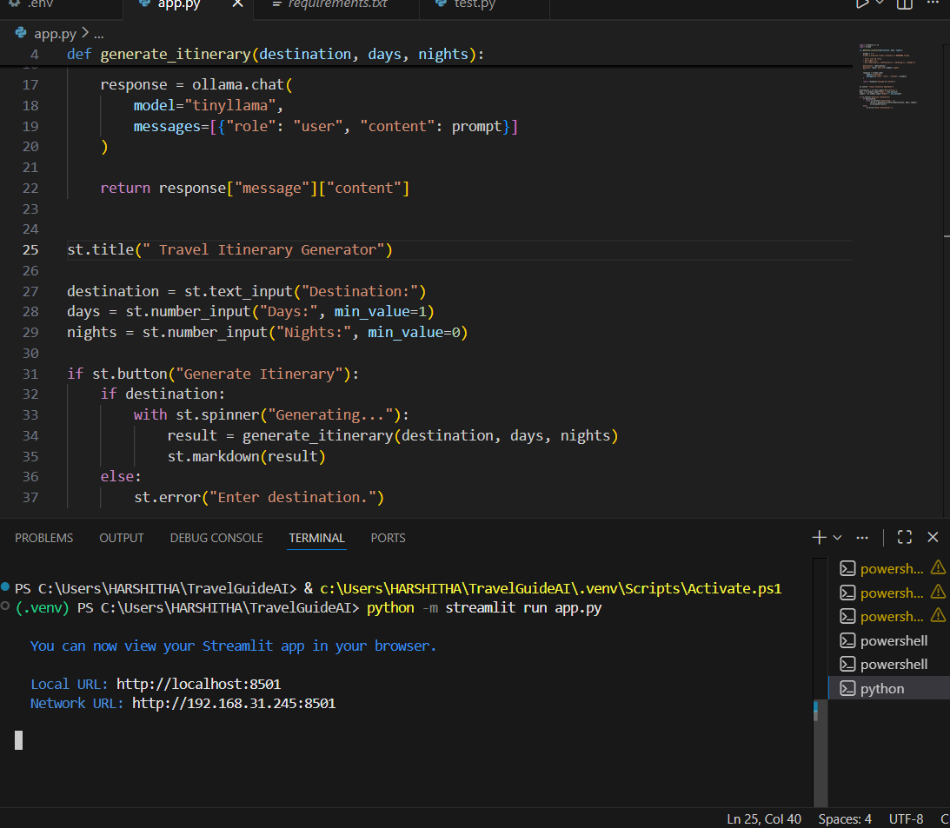

The app will open in your browser at:
http://localhost:8501

Folder Structure
explore-with-ai/
│
├── app.py
├── requirements.txt
├── .env
├── README.md
└── assets/

API Documentation
Generative AI Request
The application sends a structured prompt to the Generative AI model including:
- Destination
- Duration (Days and Nights)
- Required formatting instructions
Example Request Structure:
- Title using Markdown
- Day-wise breakdown
- Morning, Afternoon, Evening, Night sections
- Travel tips
Example Response:
## Goa Travel Itinerary

**Day 1:**
Morning: Visit Baga Beach
Afternoon: Explore Fort Aguada
Evening: Sunset at Calangute
Night: Dinner at beachside café

Authentication
Currently, authentication is not implemented as this is a single-user AI-based application.
Future versions can include:
- JWT-based authentication
- User registration and login
- Saved itinerary history

User Interface
Screens Included:
- Main Page
- Input Section
- Generate Button
- Loading Spinner
- Generated Itinerary Output
The UI focuses on simplicity and ease of use.

Testing
Testing performed includes:
- Input validation testing
- Generative AI response testing
- Performance testing
- Error handling testing
- API response verification
Tools Used:
- Manual Testing
- Streamlit Debug Mode

Screenshots or Demo
Include:
- Screenshot of Input Form
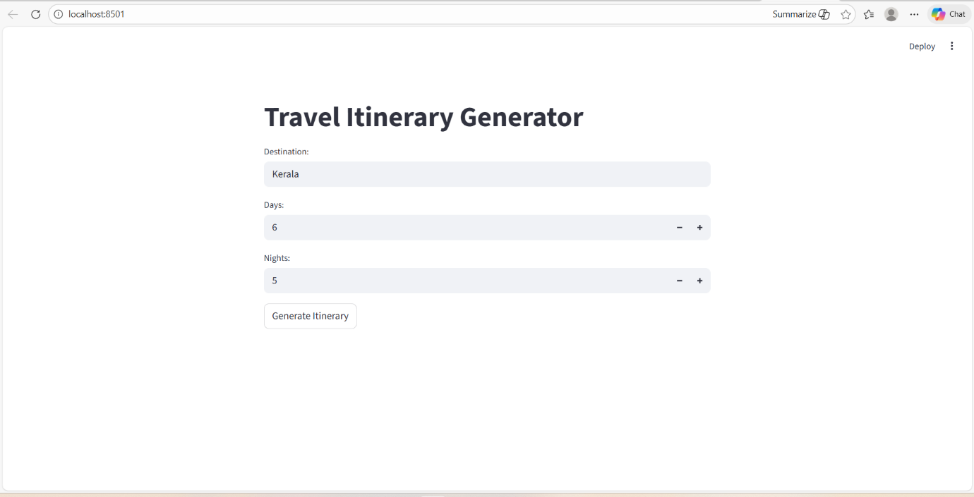

- Screenshot of Generated Itinerary
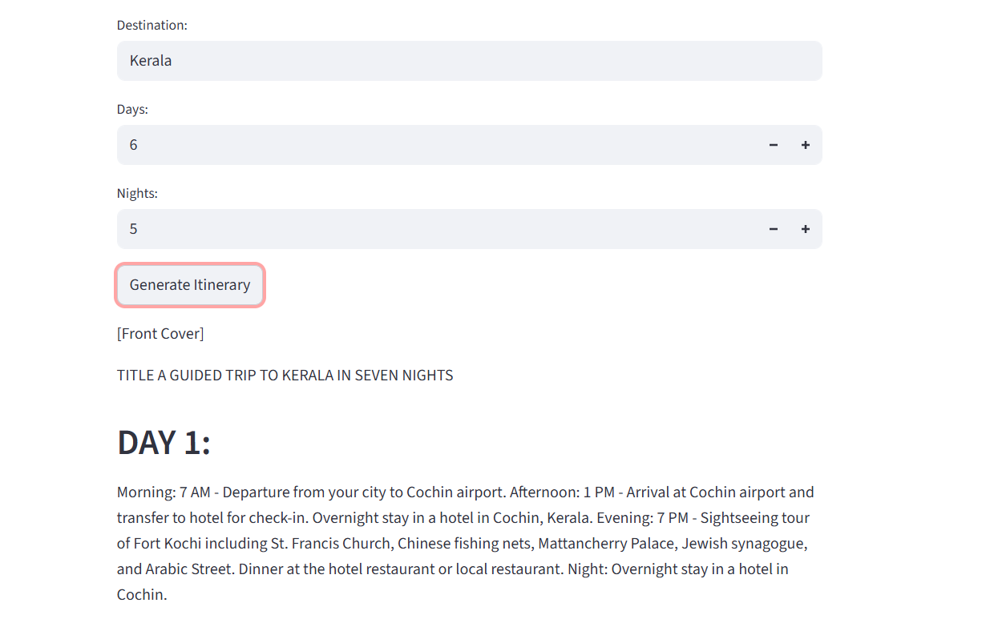
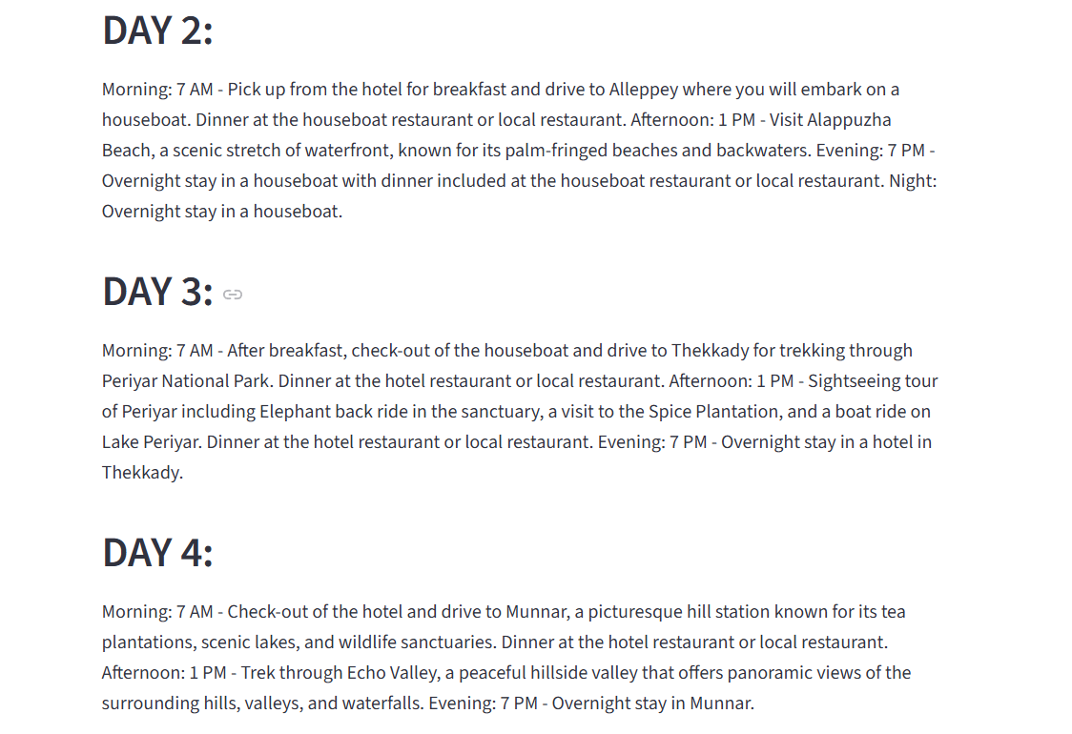

Demo Video: EXPLORE-WITH-AI-Custom-Itineraries-for-Your-Next-Journey/TravelGuide.mp4 at main · sai-harshitha-nalathoti/EXPLORE-WITH-AI-Custom-Itineraries-for-Your-Next-Journey
Github: sai-harshitha-nalathoti/EXPLORE-WITH-AI-Custom-Itineraries-for-Your-Next-Journey
Google Drive: Explore with AI: Custom Itineraries for Your Next Journey - Google Drive

Known Issues
- AI output may vary slightly
- Requires internet connection
- API rate limits may restrict requests
- No user authentication system

Future Enhancements
- Add MongoDB integration
- User login & registration
- Save itinerary history
- PDF download option
- Email sharing feature
- Multi-language support
- Budget estimation module
- Hotel & flight API integration
- Mobile application version
- Cloud deployment with auto-scaling

Conclusion
Explore with AI successfully demonstrates the integration of Generative AI into a web application for intelligent travel planning. The system automates itinerary creation, enhances user experience, and reduces manual effort in trip planning.

